**Bug Report**

8**. Plan Type** is not showing in the Downloaded **SP- service request report** as per Client Feedback.

And aslo Some of the Part details are not in the **SP-Service Request Report (Suggestion)**

10.**Dealer and Manager** is not able to download the **SP- service request Details report**only **Admin** can be able to Download

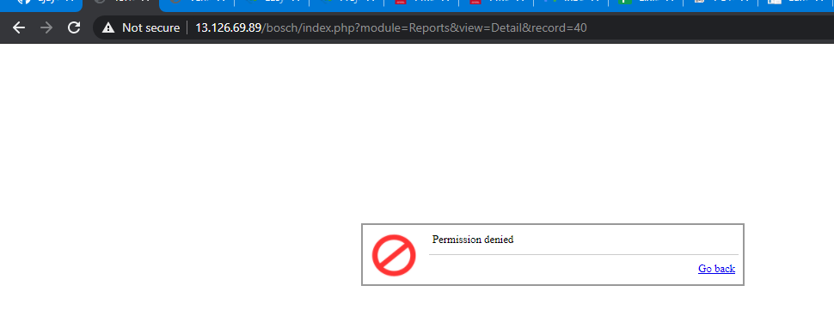

11. When User Clicks on Save Button Without Entering any data into the mandatory Fields then System Directly showing the validation message   
**“Ensure you have a selected the parts and unit value is entered correctly as per the Tax invoice”**  
Before Sowing the Validation message for to fill the Required field